**Community Site for Dog Lovers**

This project aims to provide dog owners with a platform to bond/socialize with each other and help missing dogs have high probability of being found, given a chance to return to their previous owners or get new owners, and stray dogs have the same benefit. Some features of the website include:

* Information on breeds of dogs
* Registering a dog for adoption or adopting a dog
* Reporting stray/missing dogs
* Schedule meetups for doglovers

This report contains update on the website development progress for community for dog lovers. The report is divided into three sections: database structure, backend, and frontend. For our project we will make use of the following tools: Django, wireframe, figma, bootstrap studio, github. Progress can be viewed via the link below:

<https://github.com/singla007/Dog_Community_FS>

**Database Structure**

We are using Django for our database and its structure is as shown in fig. 1. The corresponding classes have been created in the backend using the python programming language (see link below).

Fig. 1. Database structure

**Backend**

For the backend of this project, we are using the Django application. Two models.py files have been created: one for our custom_admin_portal (CAP) and the other for dog_community_app (DCA). In our DCA/models.py, we have created 7 classes: Breed, Dogs, EventSubscriptions, Events, Reports and Admin. Each class attribute has been defined and can be viewed through the link below:

<https://github.com/singla007/Dog_Community_FS/blob/main/dog_community_app/models.py>

**Frontend**

The frontend for this project is designed using bootstrap studio. The required pages needed for this project are Login, Home, Breed info, Report a dog, Meetup, Adoption, Contact and About. The skeletal framework for each page (see figure 2 and 3 for contact and report a missing dog pages in progress) have been created and once linked with the backend and database, can be viewed through the link below:

<https://github.com/singla007/Dog_Community_FS/tree/main/Templates>

We are gearing towards uniformity of the pages and are working together to achieve this.

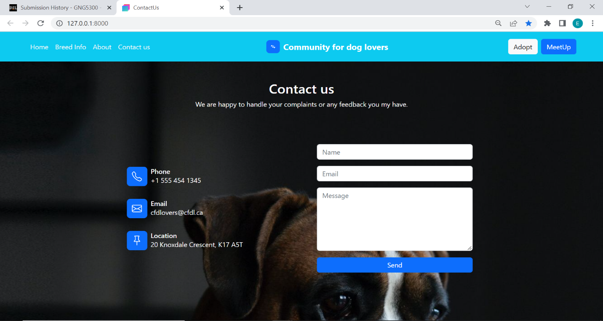

Fig. 2. Contact us page (initial draft)

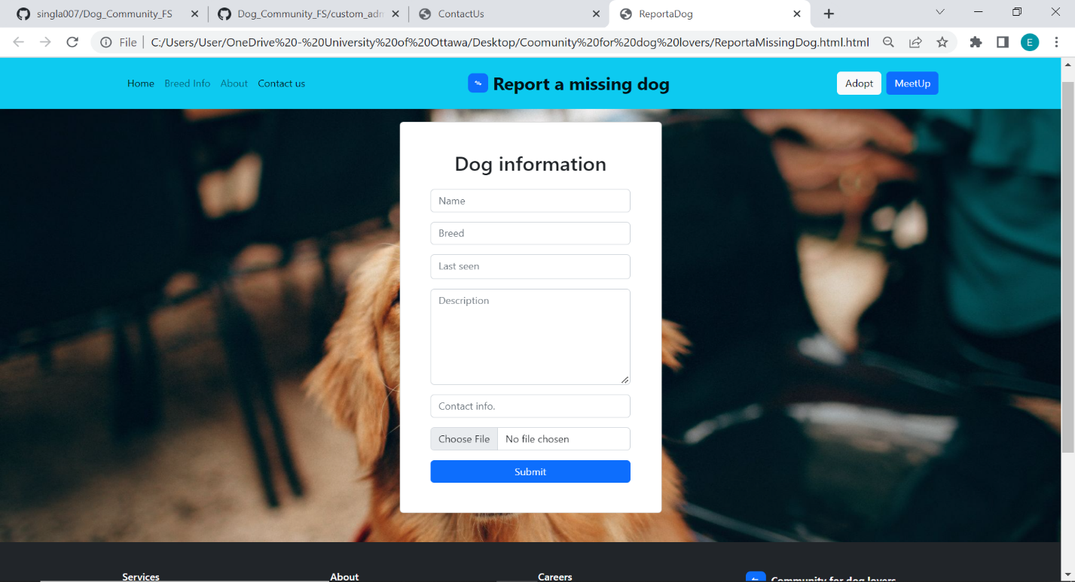

Fig. 3. Report a missing dog page (initial draft)

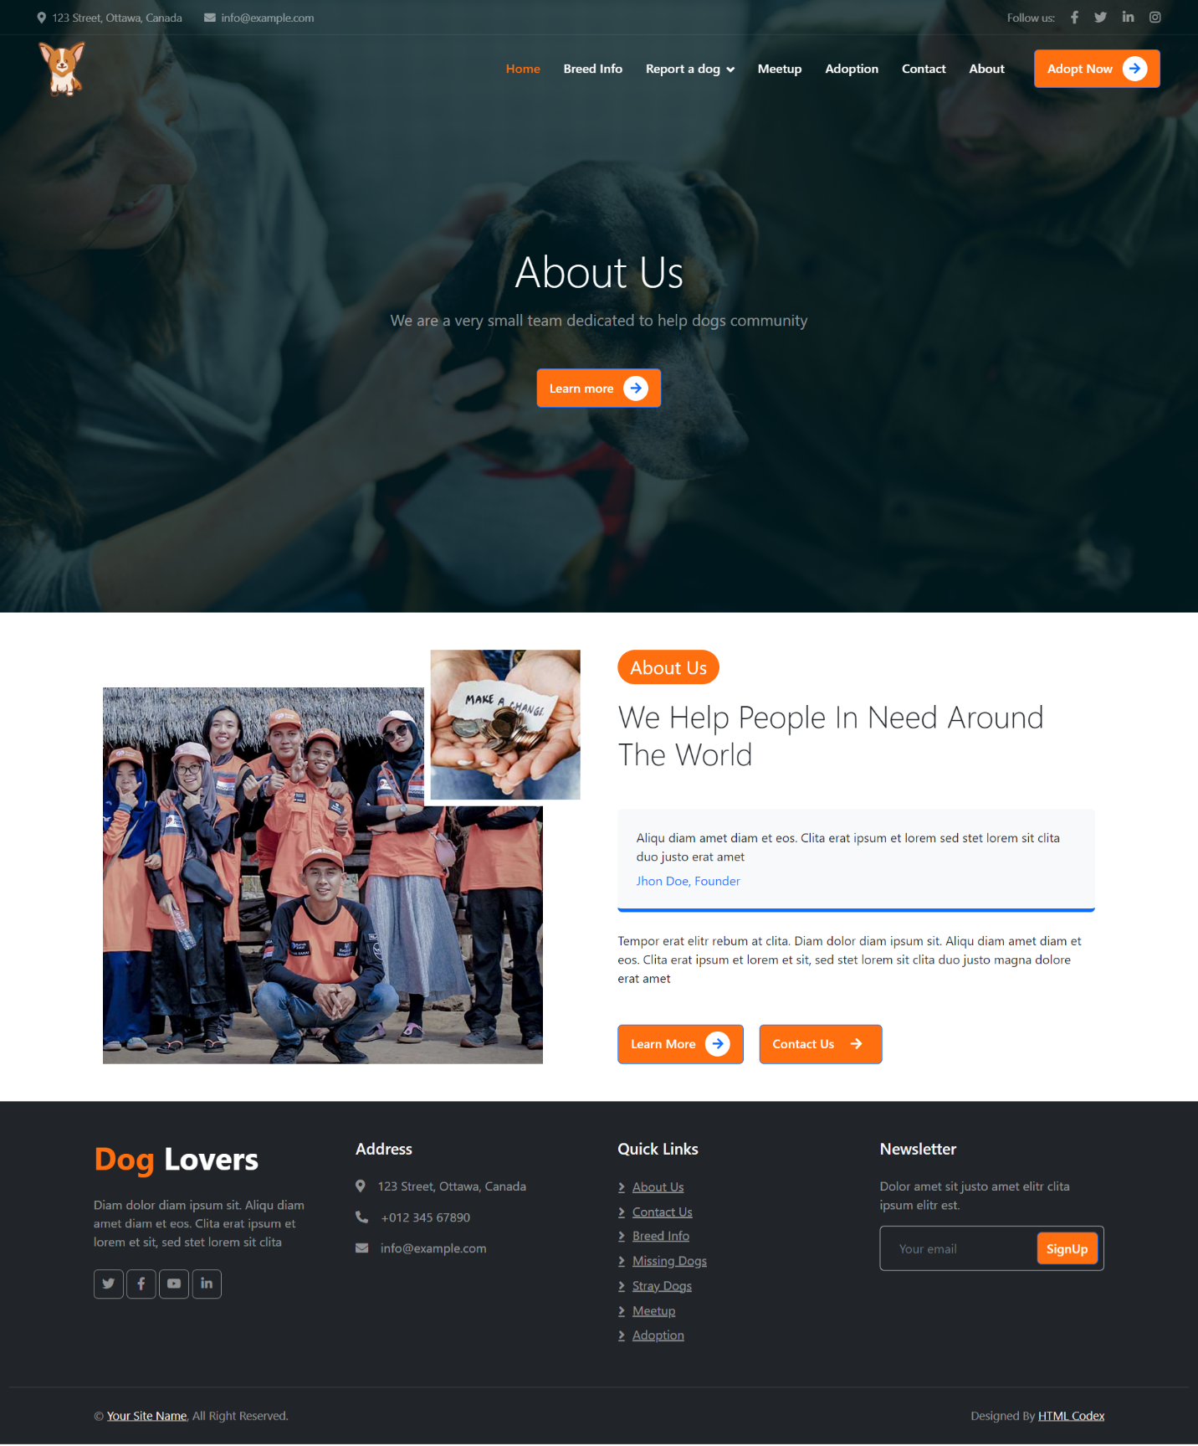

Fig. 4 About us page (initial draft)

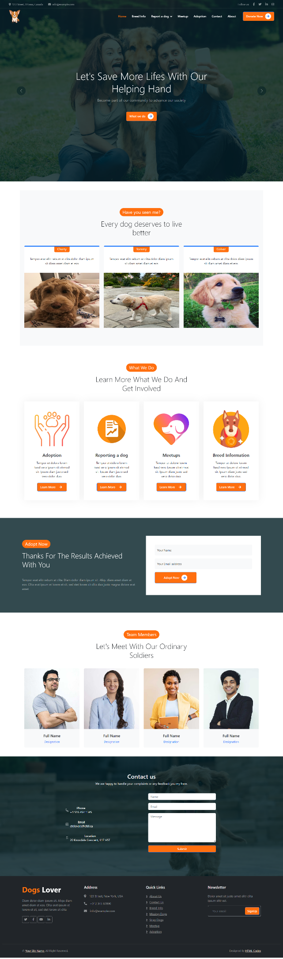 Fig 5.Home page(initial draft)

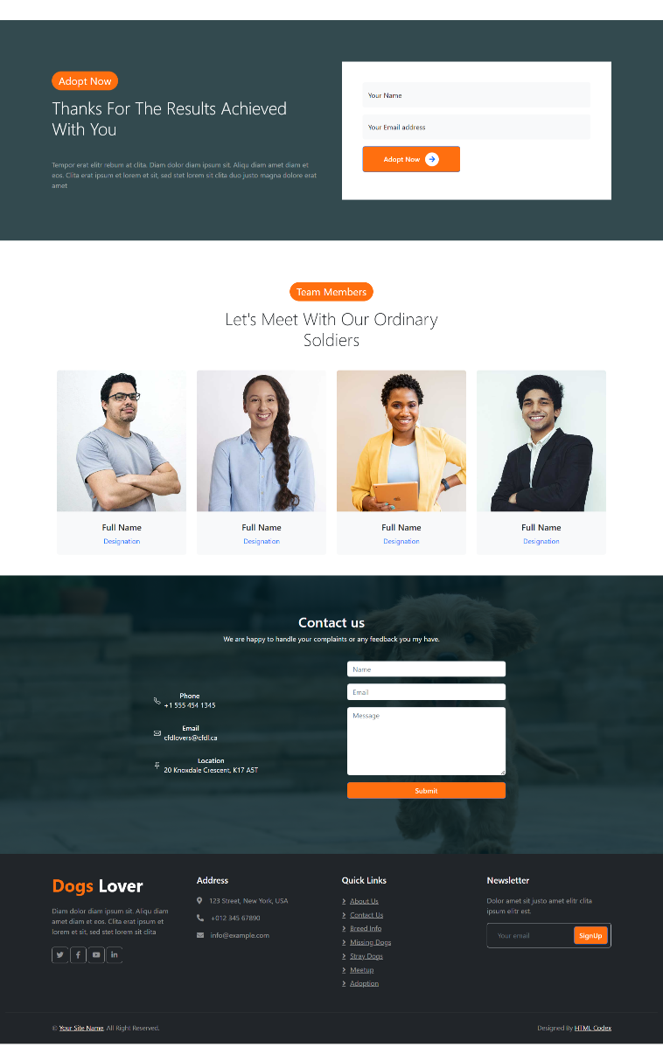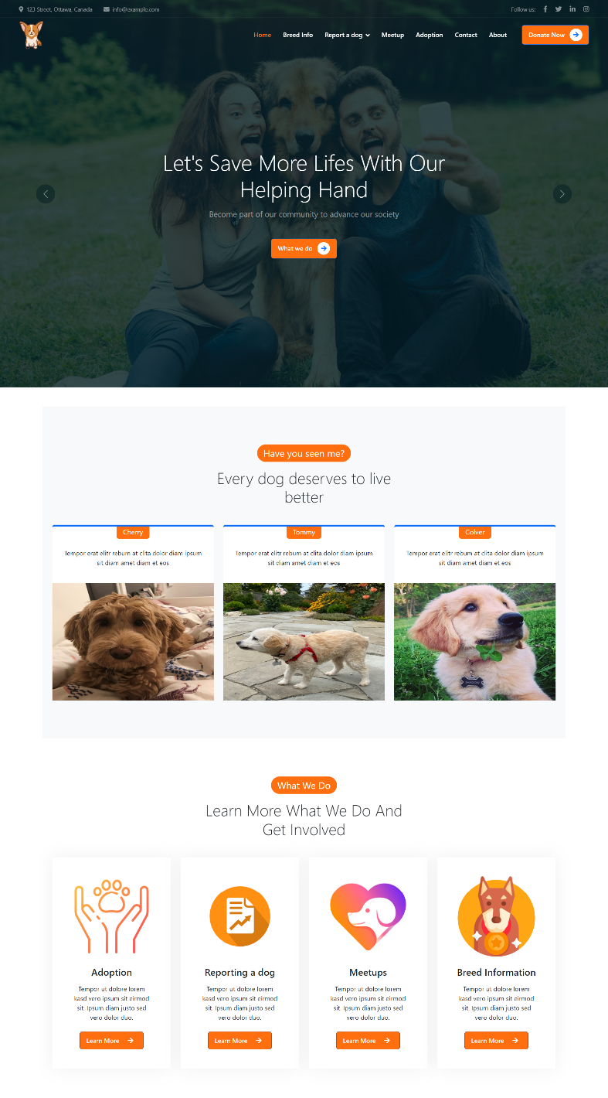Fig 6. Landing Page (Initial Drafts)